EXPERIMENT 4 240701117
Name:M.N.Dharaan

Create a prototype with familiar and unfamiliar navigation elements. Evaluate ease of use with different user groups using Proto.io
Screen 1: Sign In Page

This is the login page of the ATTYD fashion shopping application.

Familiar Icons:

- Mail Icon – Email Field

- Commonly used to indicate email input.

- Users easily recognize this as the place to enter their email ID.

- Lock Icon – Password Field

- Universally recognized symbol for password/security.

- Indicates secure login credentials.

- Login Button

- A standard call-to-action (CTA) button.

- Users understand that clicking it will allow access to the app.

Unfamiliar Elements:

- “Create One” Text Link

- Instead of a clear “Sign Up” button, the phrase might not be immediately noticeable to all users.

- Some users may overlook it.

- Minimalist Branding (“ATTYD” Header)

- Large typography branding without navigation hints may confuse first-time users.

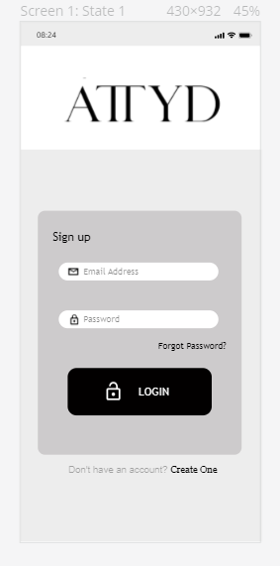

Screen 2: Home Page

This is the main shopping interface displaying trending products.

Familiar Icons:

- Search Icon – Top Bar

- Used to search products.

- Highly recognizable across all apps.

- Cart Icon – Top Right

- Universal e-commerce symbol.

- Indicates access to shopping cart.

- Category Filter Icons (All, T-shirt, Pants, etc.)

- Used for filtering product categories.

- Common in online shopping apps.

- Bottom Navigation Bar Icons:

- Home – Returns to main page.

- Search – Opens search.

- Cart – Opens cart page.

- Profile – Opens user account.

- These are highly familiar navigation elements.

Unfamiliar Icons:

- List/Grid Toggle Icon

- Some users may not immediately understand layout switching.

- Trending Arrow (→)

- May not clearly indicate “See All” functionality for first-time users.

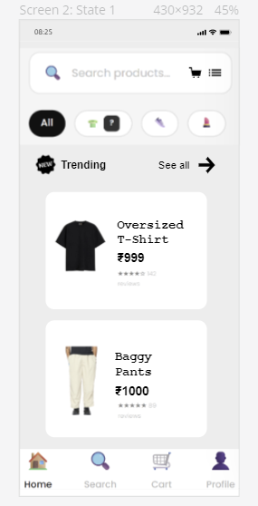

Screen 3: Product Detail Page (Oversized T-Shirt)

This screen shows detailed information about a selected product.

Familiar Icons:

- Back Arrow (←) – Top Left

- Standard navigation icon.

- Returns user to previous page.

- Heart Icon (♡) – Top Right

- Represents wishlist/favorite.

- Common in shopping apps.

- Star Rating (★★★★★)

- Indicates product reviews.

- Easily recognizable.

- “Add to Cart” Button

- Clear CTA for purchase action.

Unfamiliar Elements:

- The Like button might not be understood by the users

- Users unfamiliar with concise descriptions may look for more detailed specs.

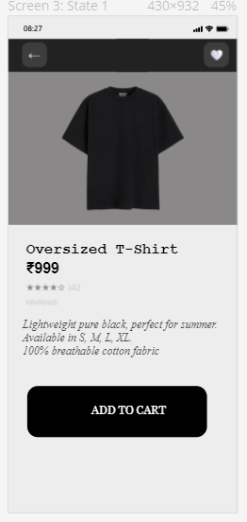

Screen 4: Cart Page

Displays selected products before checkout.

Familiar Icons:

- Back Arrow (←)

- Navigates back to shopping page.

- Plus (+) and Minus (−) Buttons

- Used to increase/decrease product quantity.

- Common in all shopping carts.

- Subtotal / Delivery / Total Section

- Standard breakdown of pricing.

- Payment Method Icons

- Credit/Debit Card

- UPI

- Cash on Delivery

- These are highly familiar to Indian users.

- “Pay” Button

- Final call-to-action to complete purchase.

Unfamiliar Elements:

- Radio Buttons for Payment Selection

- Some new users may not immediately understand selection indication.

- Static Delivery Fee Display

- Users may expect dynamic calculation.

